# 50.020 Network Security Lab 5: Linux Firewall Exploration

## Task 1: Using Firewall

IP Address of Machine A: 10.0.2.128

IP Address of Machine B: 10.0.2.129

Prevent A from doing telnet to Machine B

By default, Machine A is able to telnet Machine B:

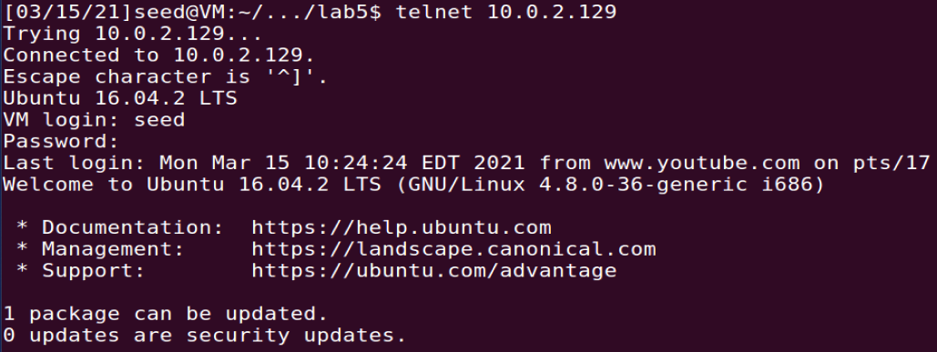

Bash commands as shown in part1.sh are executed on Machine A to implement policies in iptables:

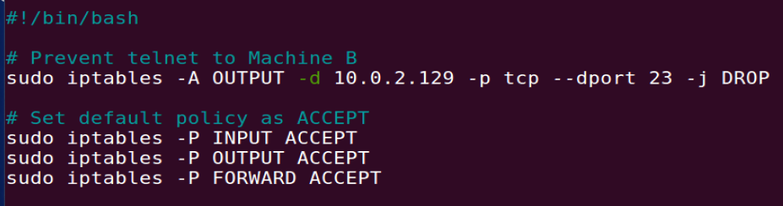

The 1st command blocks outgoing packets that are destined for B’s IP address and port number of 23 (which indicate that they are telnet packets). The 2nd, 3rd and 4th commands specify the default policy as ACCEPT, so that the additional rules declared in the filter table are for packets to be dropped or rejected.

To check that the policies are added properly, we run the following command:

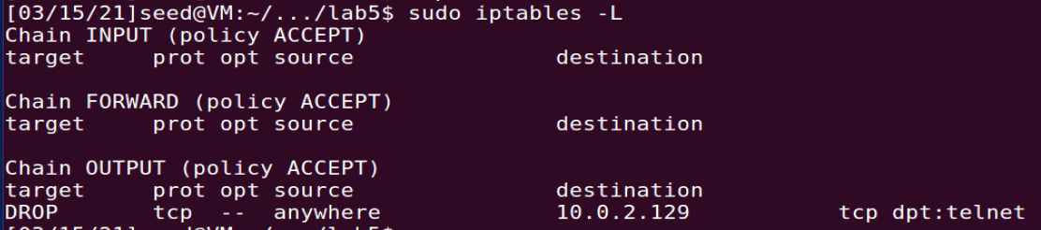

Now, Machine A is NOT able to telnet Machine B:



Before moving on, the firewall is set back to its default state by running flush.sh so as to not affect the next part of the lab:

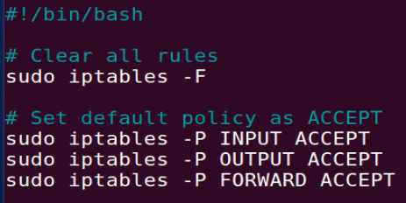

Prevent B from doing telnet to Machine A

By default, Machine A is able to telnet Machine B:

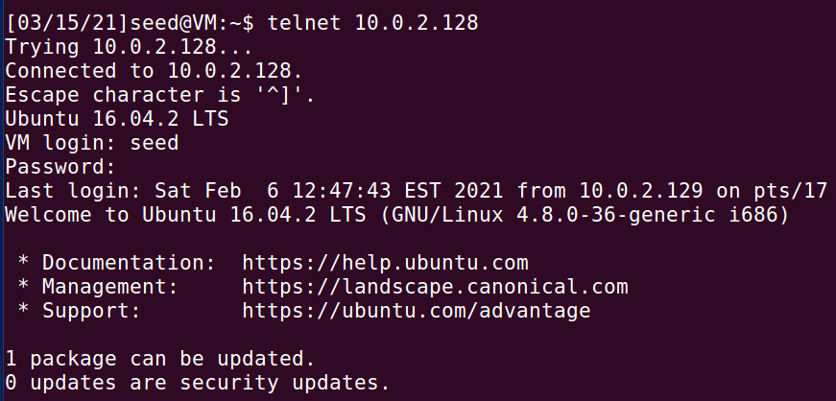

Bash commands as shown in part2.sh are executed on Machine B to implement policies in iptables:

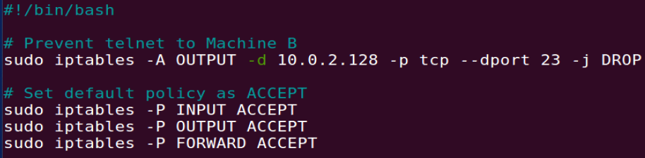

The 1st command blocks outgoing packets that are destined for A’s IP address and port number of 23 (which indicate that they are telnet packets). The 2nd, 3rd and 4th commands specify the default policy as ACCEPT, so that the additional rules declared in the filter table are for packets to be dropped or rejected.

To check that the policies are added properly, we run the following command:

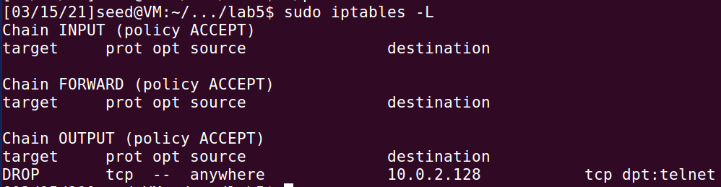

Now, Machine B is NOT able to telnet Machine A:



Before moving on, the firewall is set back to its default state by running flush.sh so as to not affect the next part of the lab:



Prevent A from visiting an external website

Website chosen: www.y8.com

By default, Machine A can visit [www.y8.com](http://www.y8.com):

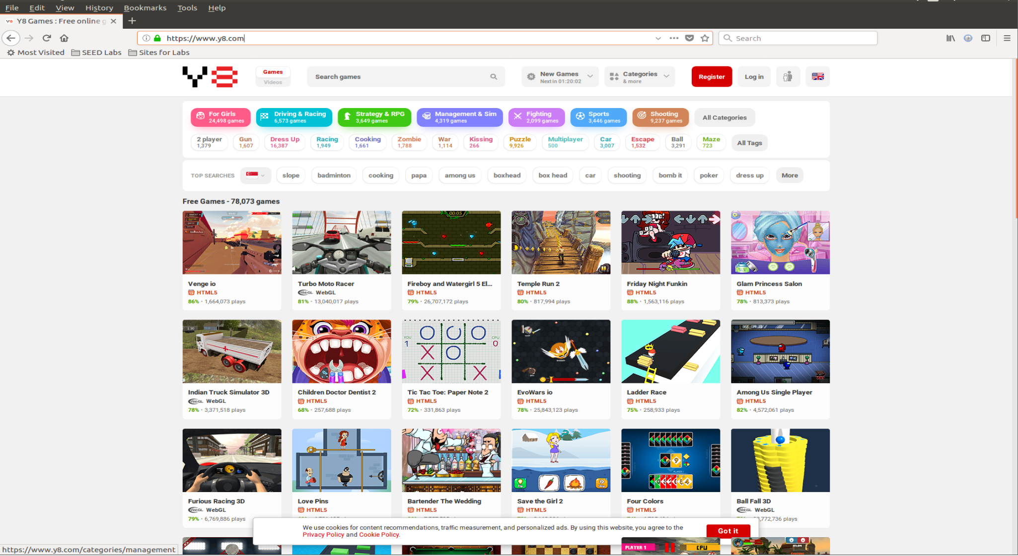

The dig command is used to resolve the hostname to its IP address(es):

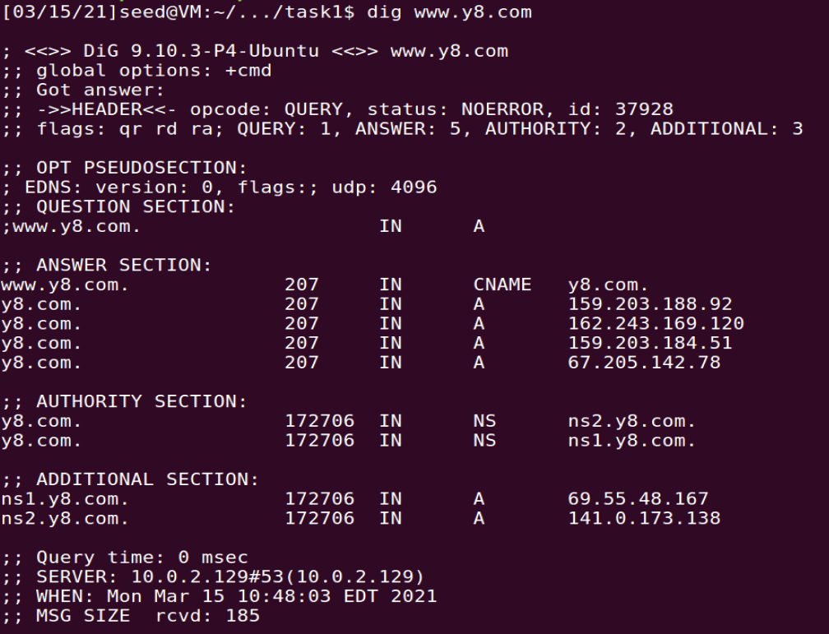

Bash commands as shown in part3.sh are executed on Machine B to implement policies in iptables:

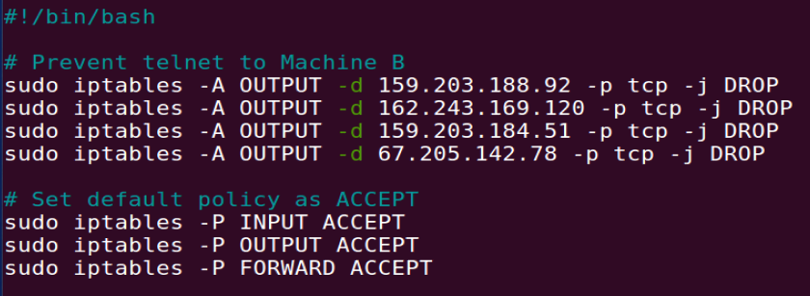

The first 4 commands block outgoing packets that are destined for www.y8.com’s IP addresses. The remaining commands specify the default policy as ACCEPT, so that the additional rules declared in the filter table are for packets to be dropped or rejected.

To check that the policies are added properly, we run the following command:

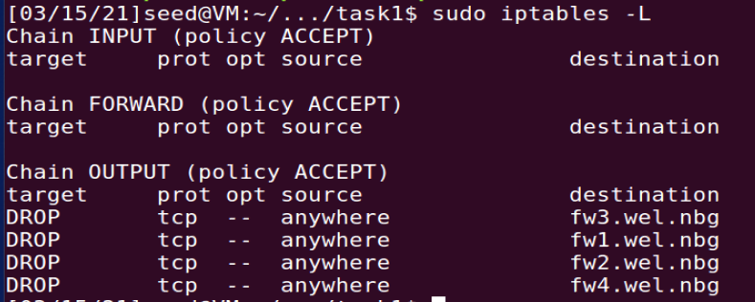

Now, Machine A is NOT able to visit [www.y8.com](http://www.y8.com) as the page can never load:

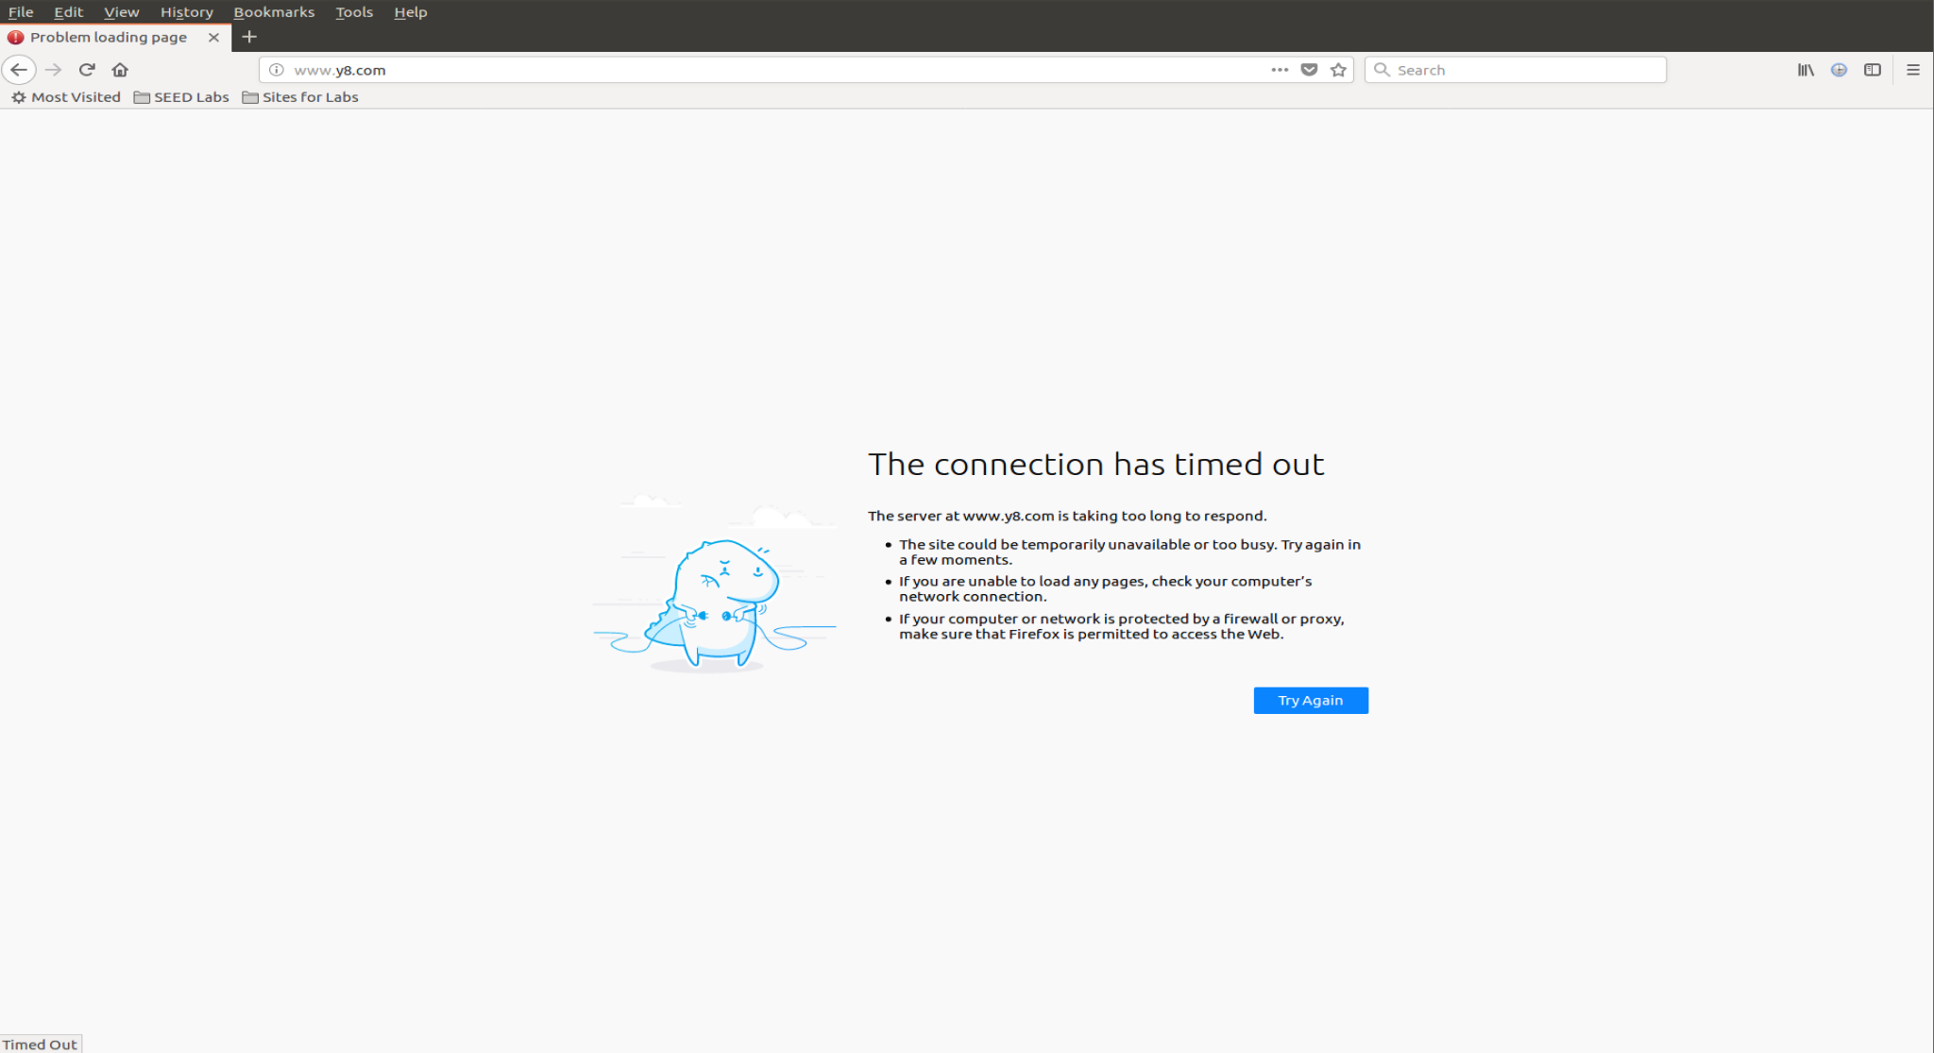

Before moving on, the firewall is set back to its default state by running flush.sh so as to not affect the next part of the lab:



## Task 2: Implementing a Simple Firewall

Rule 1: Drop all packets

Refer to the C code written in rule1.c. The code is written to drop all incoming packets.

The Makefile is written as shown:

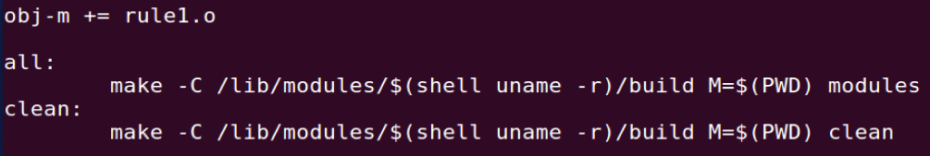

The make command is executed and the various library files are created in the current directory:

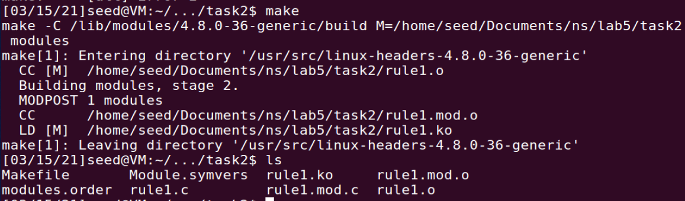

Before the kernel module is inserted, Machine B can ping Machine A:

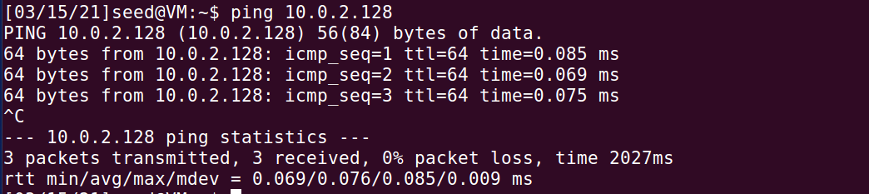

The module is then inserted into the kernel on Machine A:

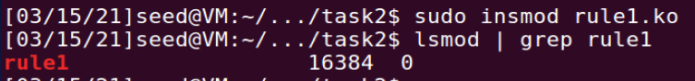

Now, Machine B is unable to ping Machine A:

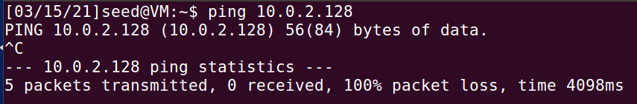

To clean up, the following command is run to remove the module from the kernel:



Rule 2: Prevent A from doing telnet to Machine B

To achieve this, on Machine A, all packets that are outgoing packets (not including forwarded packets) that are telnet packets destined for Machine B should be dropped. Refer to the C code written in rule2.c.

The Makefile is written as shown:

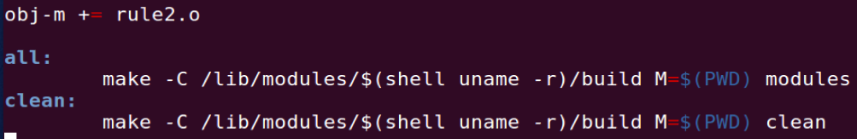

The make command is executed and the various library files are created in the current directory:

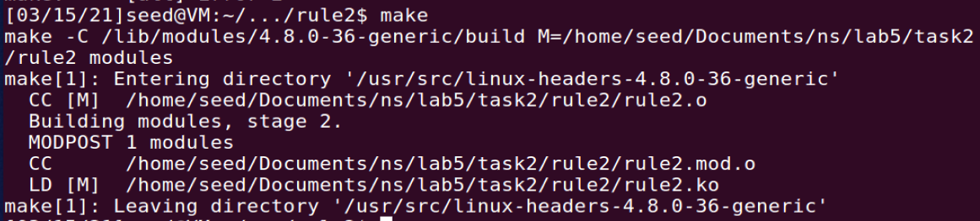

Before the kernel module is inserted, Machine A can telnet Machine B:

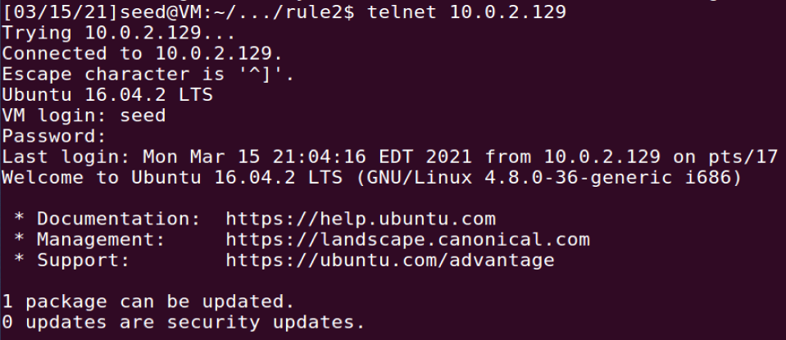

The module is then inserted into the kernel on Machine A:

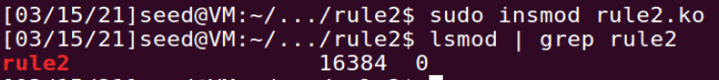

Now, Machine A is unable to telnet Machine B:



To clean up, the following command is run to remove the module from the kernel:



Rule 3: Prevent B from doing telnet to Machine A

To achieve this, on Machine B, all packets that are outgoing packets (not including forwarded packets) that are telnet packets destined for Machine A should be dropped. Refer to the C code written in rule3.c.

The Makefile is written as shown:

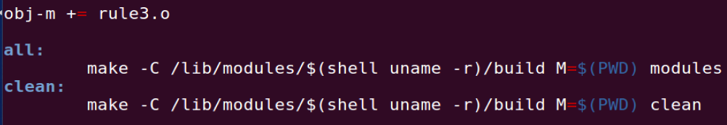

The make command is executed and the various library files are created in the current directory:

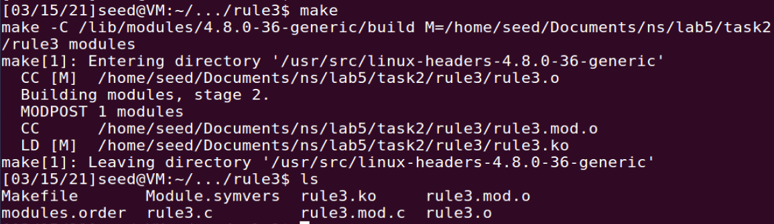

Before the kernel module is inserted, Machine B can telnet Machine A:

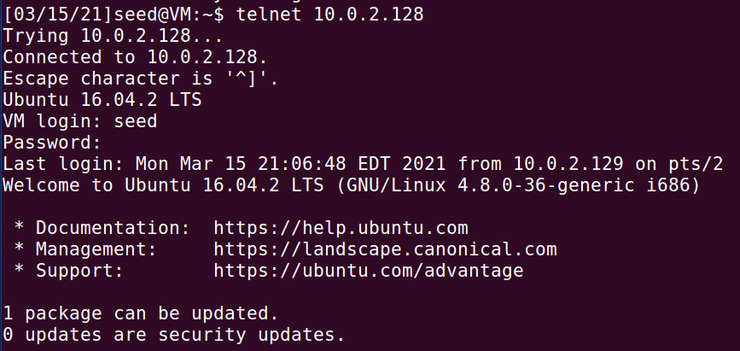

The module is then inserted into the kernel on Machine B:

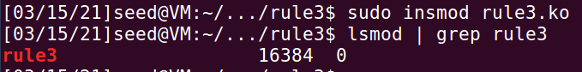

Now, Machine B is unable to telnet Machine A:

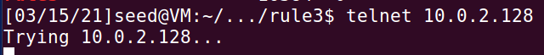

To clean up, the following command is run to remove the module from the kernel:



Rule 4: Prevent A from visiting an external web site

Website chosen: www.y8.com

From previous task, dig is used to get the IP address of the website:

* 67.205.142.78
* 159.203.188.92
* 159.203.184.51
* 162.243.169.120

To achieve this, on Machine A, all packets that are outgoing packets (not including forwarded packets) destined for these IP addresses should be dropped. Refer to the C code written in rule4.c.

The Makefile is written as shown:

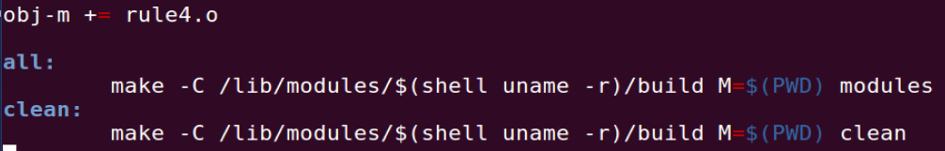

The make command is executed and the various library files are created in the current directory:

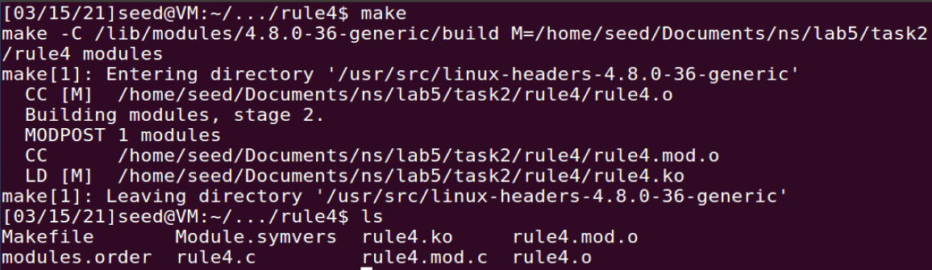

Before the kernel module is inserted, Machine A can visit [www.y8.com](http://www.y8.com):



The module is then inserted into the kernel on Machine A:

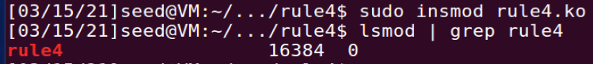

Now, Machine A is unable to visit [www.y8.com](http://www.y8.com):

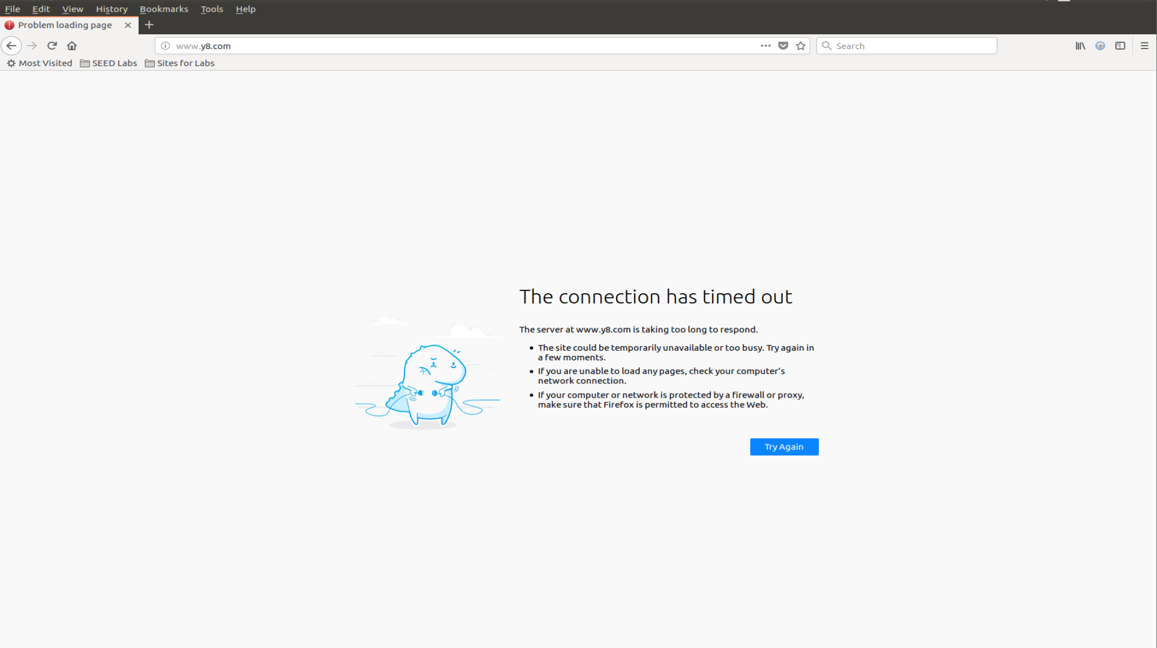

To clean up, the following command is run to remove the module from the kernel:



Rule 5: Prevent A from getting any telnet connections

To achieve this, on Machine A, all incoming packets that are telnet packets destined for Machine A should be dropped. Refer to the C code written in rule5.c.

The Makefile is written as shown:

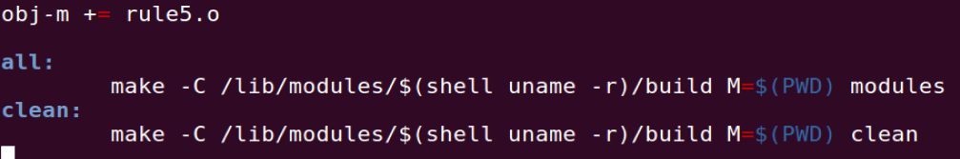

The make command is executed and the various library files are created in the current directory:

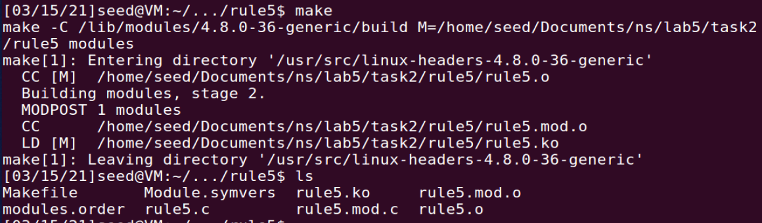

Before the kernel module is inserted, Machine B can telnet Machine A:

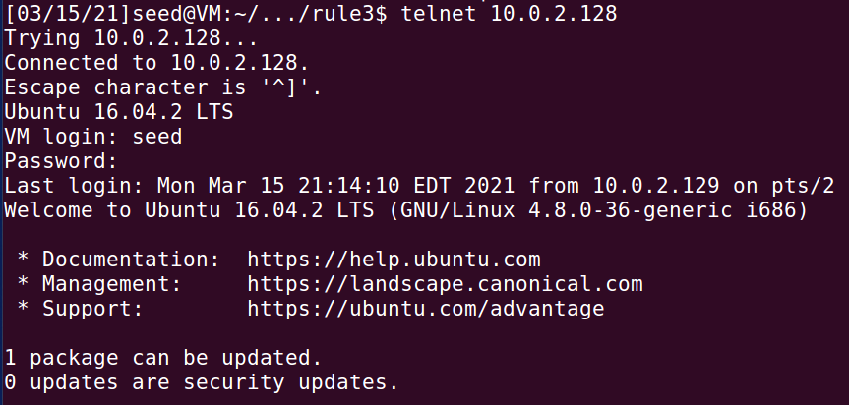

…and Machine C can telnet Machine A:

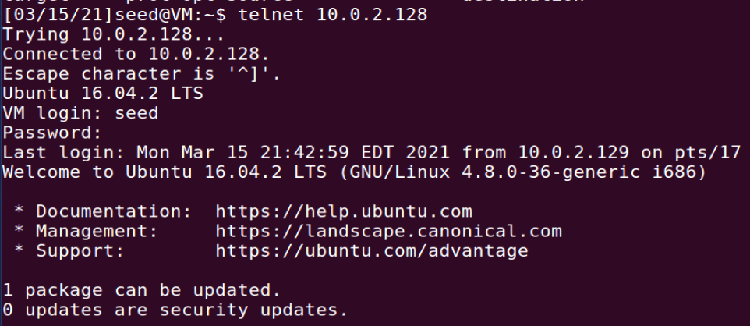

The module is then inserted into the kernel on Machine A:

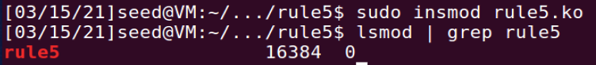

Now, Machine B is unable to telnet Machine A:



…and Machine C is unable to telnet Machine A:

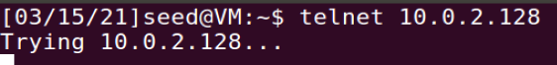

To clean up, the following command is run to remove the module from the kernel:



## Task 3: Evading Egress Filtering

IP Address of Machine A: 10.0.2.128

IP Address of Machine B: 10.0.2.129

IP Address of Machine C: 10.0.2.130

Block all the outgoing traffic to external telnet servers

Before the Firewall is set up, Machine A is able to telnet Machine B:

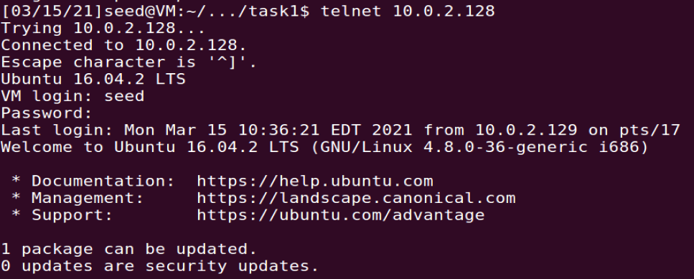

…as well as Machine C:  
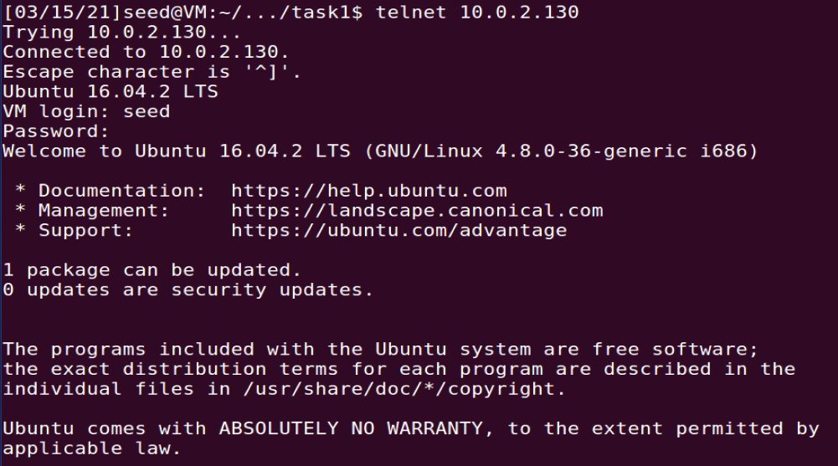

Bash commands as shown in block_telnet.sh are executed on Machine A to implement policies in iptables:

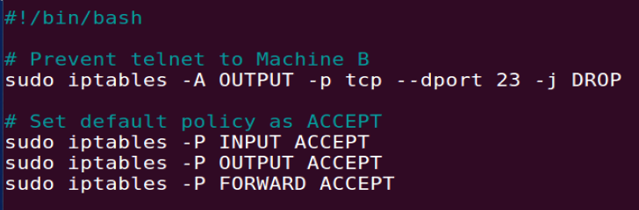

The first command blocks outgoing telnet packets. The remaining commands specify the default policy as ACCEPT, so that the additional rules declared in the filter table are for packets to be dropped or rejected.

To check that the policies are added properly, we run the following command:

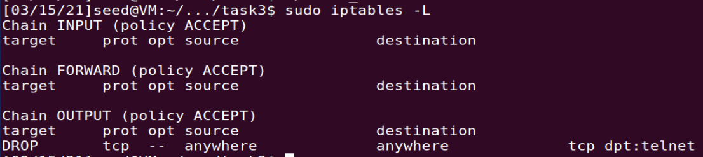

Now, Machine A is NOT able to telnet Machine B:



…as well as Machine C:



Block all the outgoing traffic to www.facebook.com

Before the Firewall is set up, Machine A is able to visit [www.facebook.com](http://www.facebook.com):

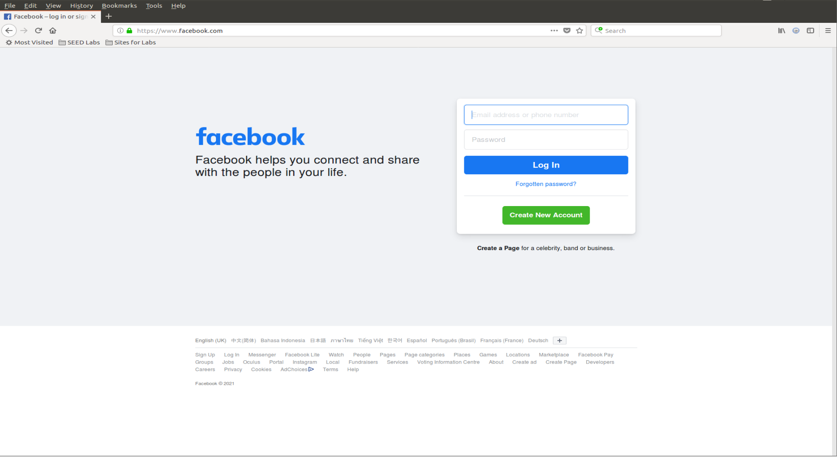

The dig command is used to resolve the www.facebook.com to its IP address(es):

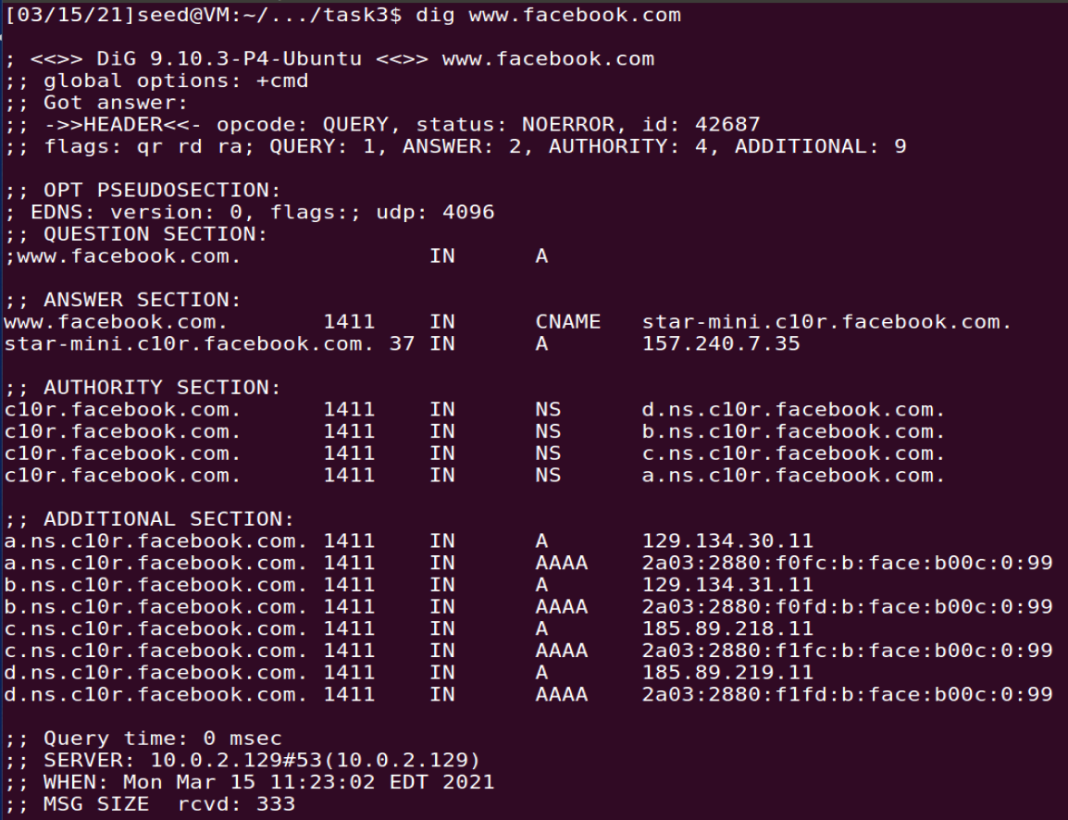

Bash commands as shown in block_facebook.sh are executed on Machine A to implement policies in iptables:

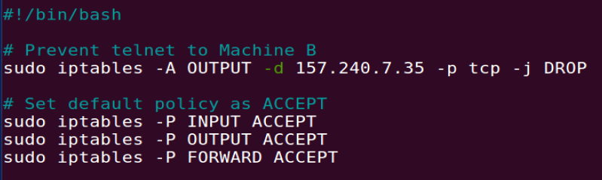

The first commands blocks outgoing packets that are destined for www.facebook.com. The remaining commands specify the default policy as ACCEPT, so that the additional rules declared in the filter table are for packets to be dropped or rejected.

To check that the policies are added properly, we run the following command:

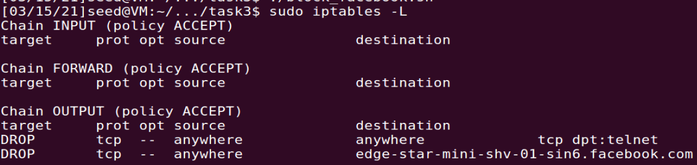

Now, Machine A is NOT able to visit [www.facebook.com](http://www.facebook.com):

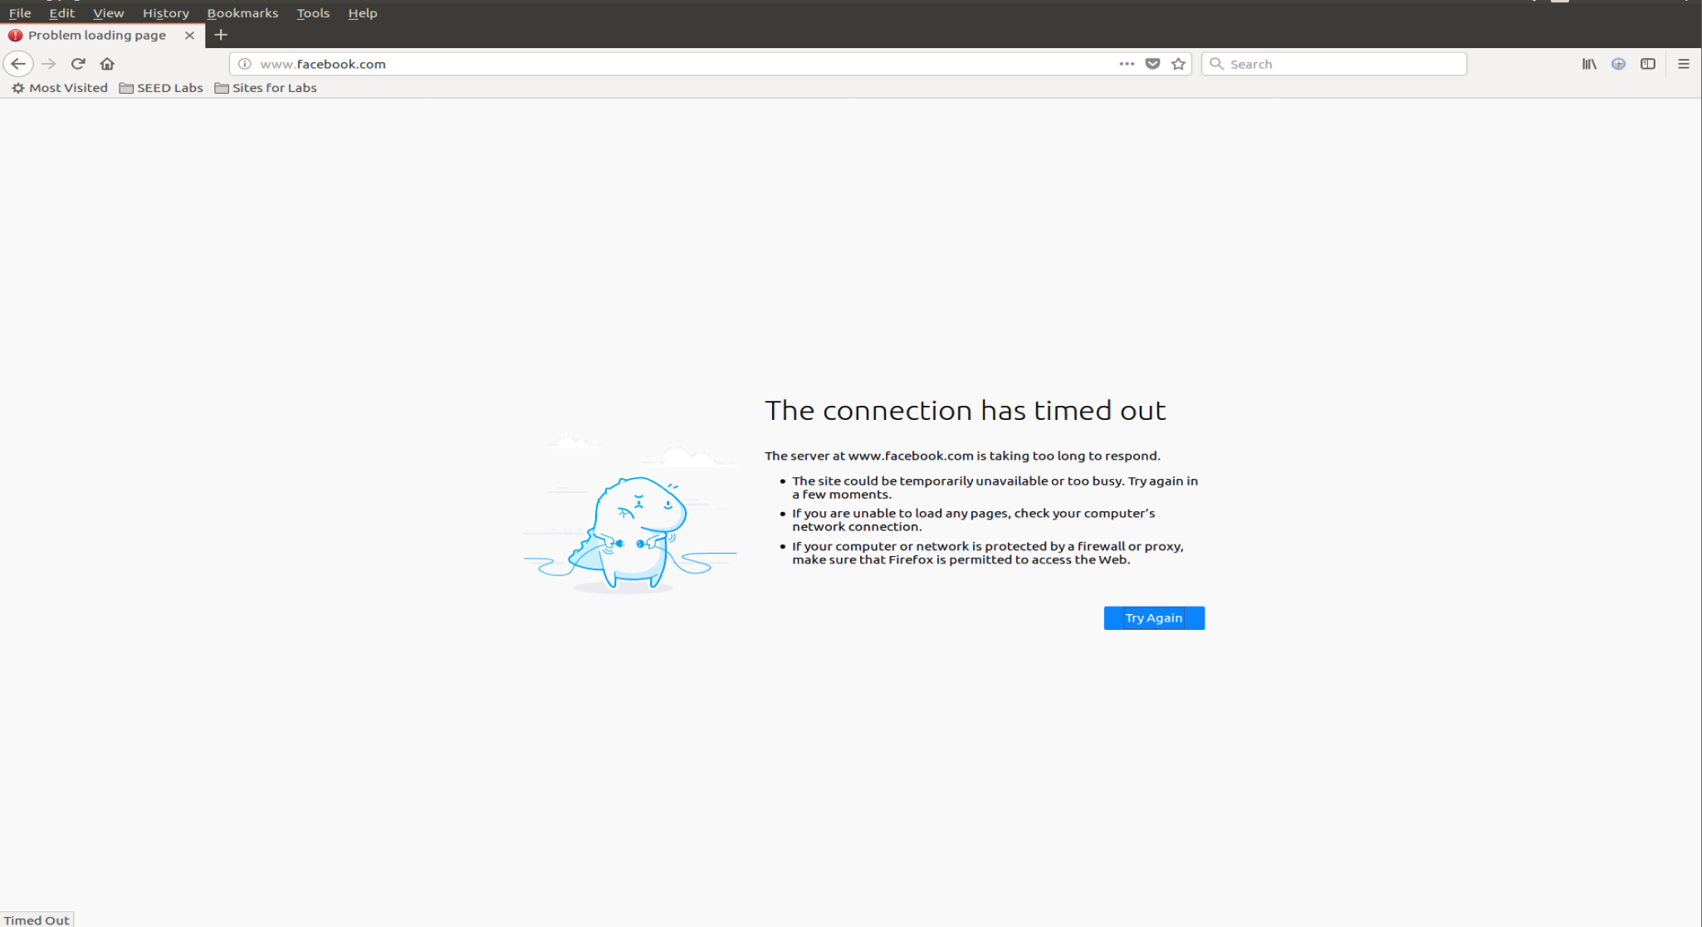

**Task 3a: Telnet to Machine B through the firewall**

To establish an SSH tunnel between Machine A and B and get the tunnel to forward TCP data received on port 8000 on Machine A to port 23 on Machine C, the following command is run on Machine A:

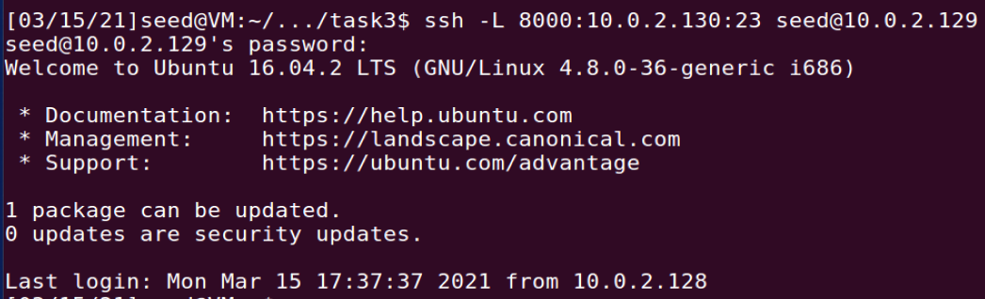

To telnet to Machine C via the tunnel, the following command is run on a new terminal on Machine A:

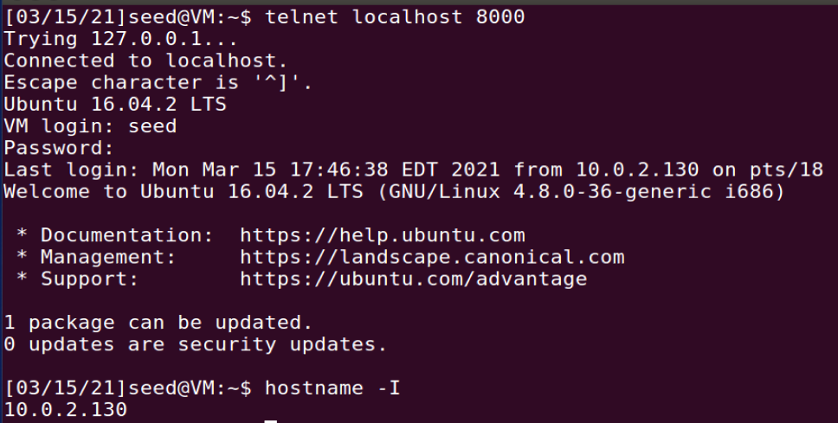

We have successfully telnet to Machine C from Machine A through a ssh tunnel between Machine A and Machine B!

**Task 3b: Connect to Facebook using SSH Tunnel**

To establish an SSH tunnel between Machine A port 9000 and Machine B using dynamic port forwarding, the following command is run on Machine A:

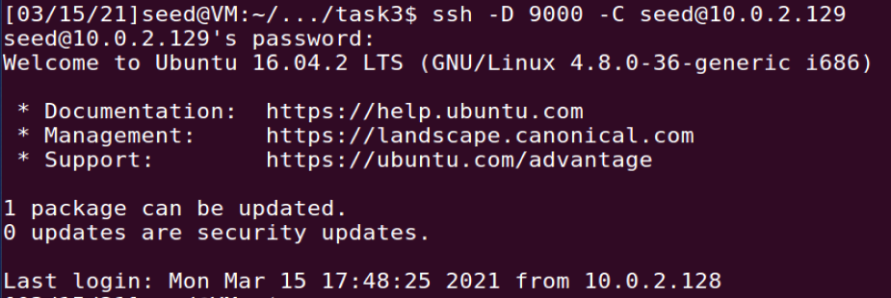

To ask Firefox to connect to localhost:9000 every time it needs to connect to a web server, we set up te SOCKS proxy in Firefox:

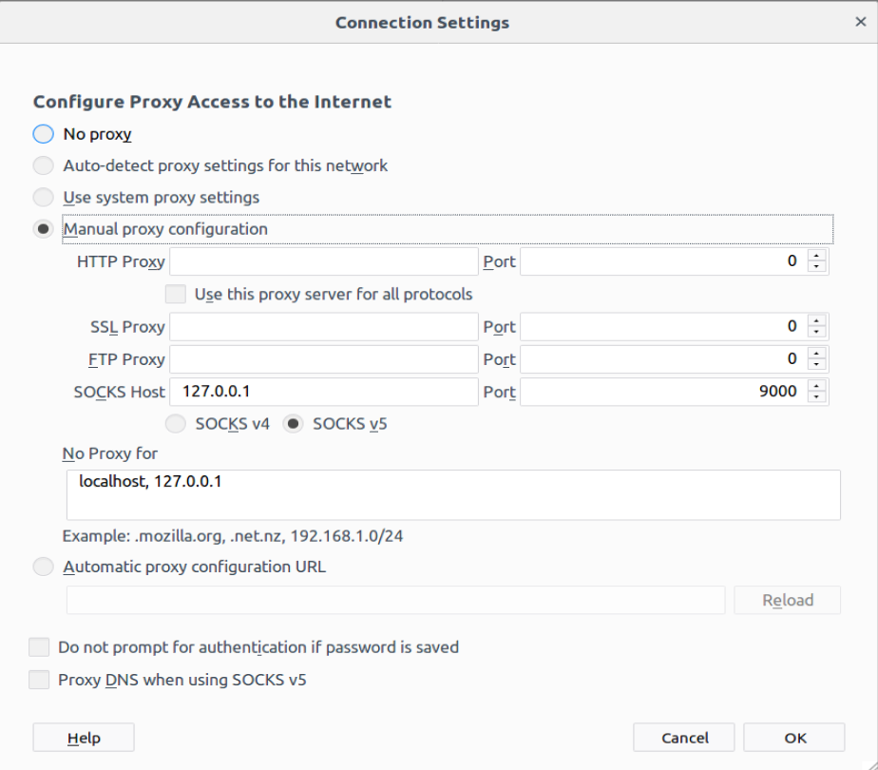

1. Run Firefox and go visit the Facebook page. Can you see the Facebook page? Please describe your observation.

Yes, the Facebook page can be seen:

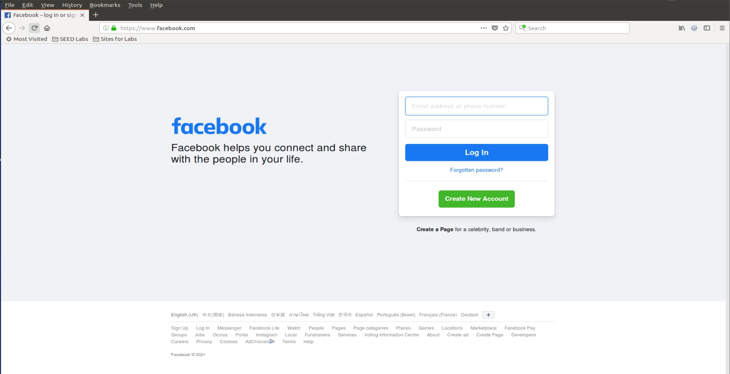

2. After you get the facebook page, break the SSH tunnel, clear the Firefox cache, and try the connection again. Please describe your observation.

The SSH tunnel is broken as shown:

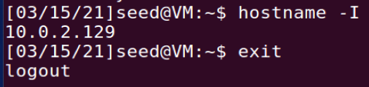

The browser’s cache is cleared and the connection is tried again:

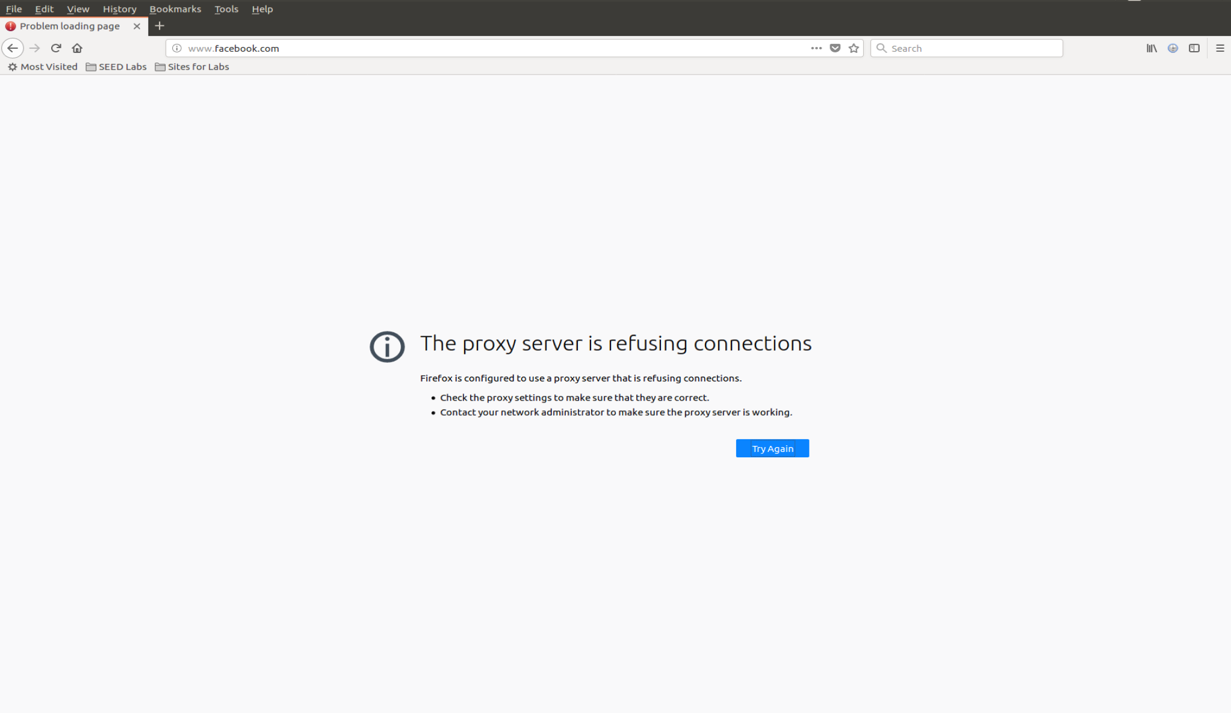

As shown, the page does not load and the reason given is that the proxy server is refusing connections. This is expected because the SSH tunnel is broken and the proxy is no longer in place.

3. Establish the SSH tunnel again and connect to Facebook. Describe your observation.

The SSH tunnel is re-established:

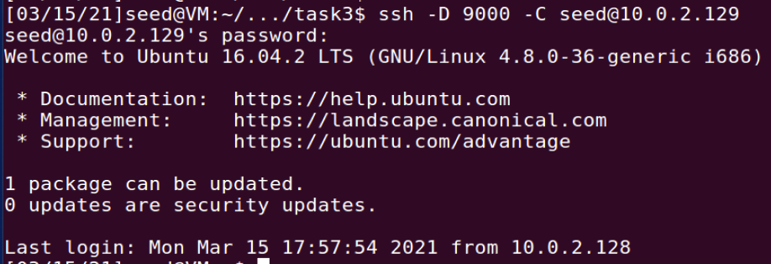

The Facebook page is successfully reloaded:

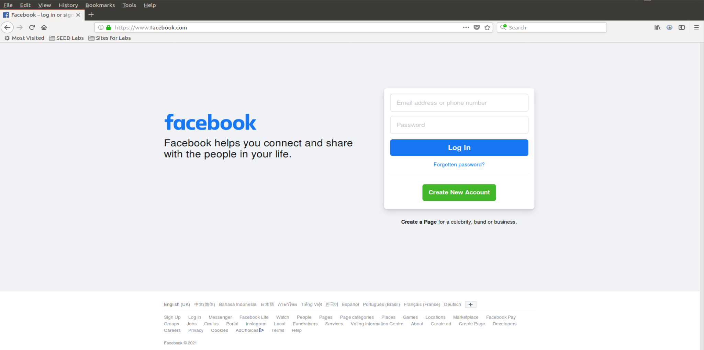

4. Please explain what you have observed, especially on why the SSH tunnel can help bypass the egress filtering. You should use Wireshark to see what exactly is happening on the wire. Please describe your observations and explain them using the packets that you have captured.

As the SSH tunneling is set up and Firefox is configured to connect to localhost:9000 every time it needs to connect to a web server, the HTTP requests are sent to localhost:9000 and in turn forwarded to Machine B via the SSH tunnel. Machine B then forwards these packets to [www.facebook.com](http://www.facebook.com) when the HTTP request is sent to [www.facebook.com](http://www.facebook.com) to render their webpage on Machine A’s browser. The Wireshark screenshot below captures the packets that are forwarded to Machine B before they are sent to [www.facebook.com’s](http://www.facebook.com's) IP address.

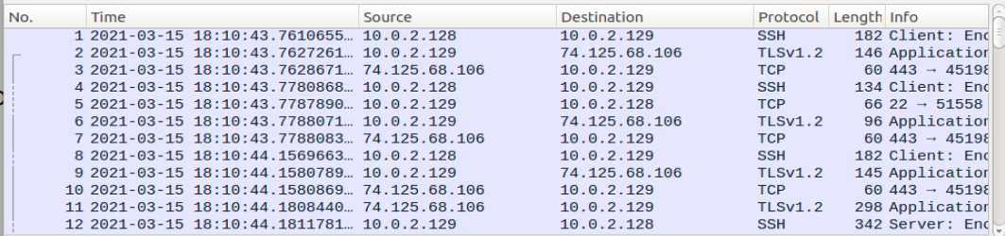

Since Machine A drops outgoing packets destined for [www.facebook.com](http://www.facebook.com) (egress filtering), it is not able to load the webpage on its own. By using SSH tunneling, it sends out the HTTP requests via SSH to Machine B, before these requests are forwarded to [www.facebook.com](http://www.facebook.com). This way, the egress filtering is bypassed.

## Task 4: Evade Ingress Filtering

IP Address of Machine A: 10.0.2.128

IP Address of Machine B: 10.0.2.129

Setting up the Firewall on Machine A

Machine A runs a simple HTTP server with the following contents from index.html:

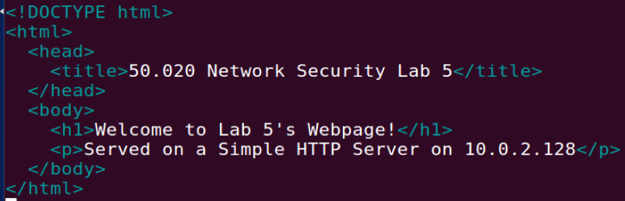

To start the server on port 80, the following command is run on Machine A:



Before the firewall is set up, Machine B can visit the website served by Machine A:  
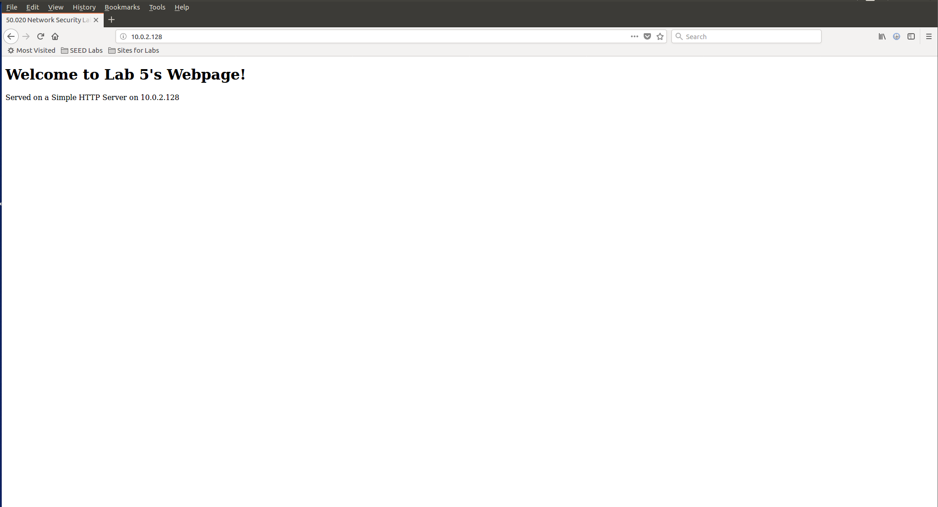

…as well as SSH to Machine A:

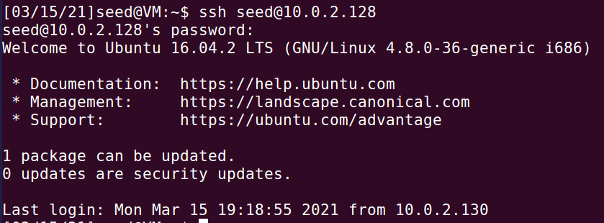

Bash commands as shown in block_task4.sh are executed on Machine A to implement policies in iptables:

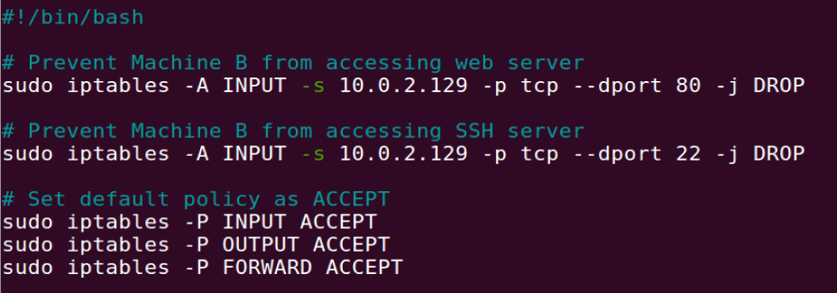

The first command blocks incoming telnet packets from Machine B. The second command blocks incoming HTTP requests from Machine B. The remaining commands specify the default policy as ACCEPT, so that the additional rules declared in the filter table are for packets to be dropped or rejected.

To check that the policies are added properly, we run the following command:

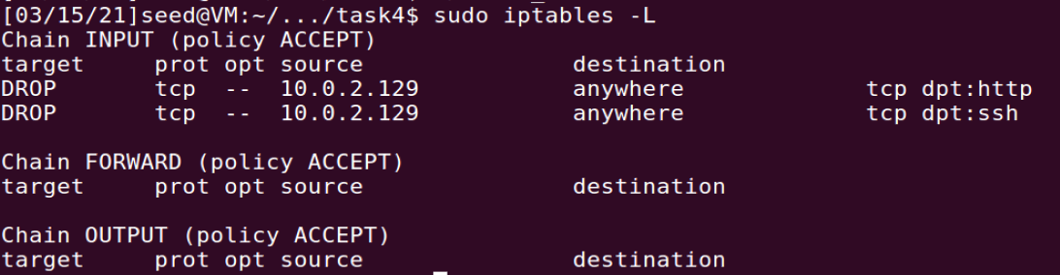

Now, Machine B cannot visit the website served by Machine A:

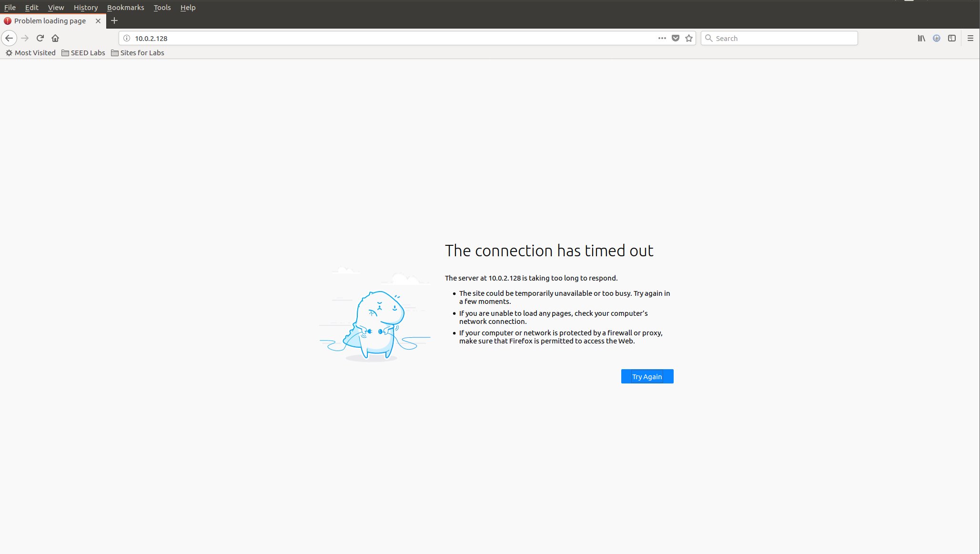

…as well as SSH to Machine A:



Setting up a Reverse SSH tunnel on Machine A

A reverse SSH tunnel is set up by running the following command on Machine A:

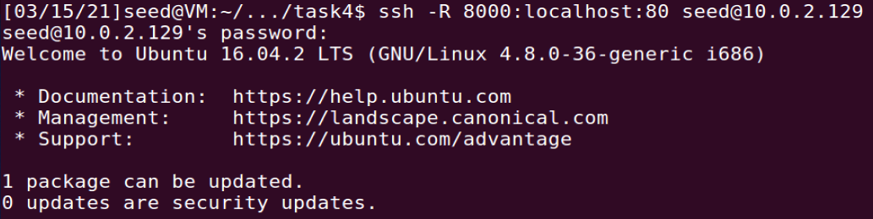

This forwards the connections given to port 8000 on Machine B to Machine A via the reverse SSH tunnel and then to localhost:80 on Machine A’s side.

Machine B can then access Machine A’s website by typing localhost:8000 into the browser:

